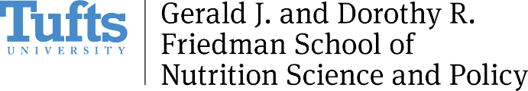

COVID-19 Remote Work Plan

During the COVID-19 pandemic response, Friedman School staff and faculty are working remotely, which is a substantial shift from standard work practices for most community members. Managers and staff members should have clear conversations about work expectations during this time and it is recommended they create documented work plans that outline how teams will interact remotely. Some topics for discussion are included below.

Contact Ruth Baylis, Human Resources Partner, with questions, issues, and concerns about employee relations: ruth.baylis@tufts.edu, 617-627-5537.

Meetings
Discuss how to incorporate changes to meetings, add new meetings, change format of meetings, duration of meetings, participants of meetings. Consider:
- Daily Brief, a X-minute per person sharing of daily work plan, due dates, meeting schedule, etc. via WebEx/Zoom between team members and supervisor
- Weekly team meeting via video WebEx/Zoom
- Weekly individual 1:1 check-ins via video WebEx/Zoom or phone call
- Individual meetings with other colleagues
- Planned trainings to be moved to WebEx/Zoom where possible and postponed where not

Tools
Discuss what tools are best suited for ongoing work, including changes to how works is done remotely. Ensure staff are trained and able to access needed tools.
- Create and refer to shared calendars
- Box will be used for file sharing
- Staff will log into Cisco Jabber and/or Skype during working hours to facilitate ad hoc communication needs, impromptu questions, meeting requests.

Communications
Discuss standard practices for ease of communication between and beyond the team. Consider:
- Staff will include within email signatures a note explaining remote working situation and scheduled working hours.
- Staff will add Skype username to signature to facilitate ad hoc communication.
- Personal cell phone/home phone numbers will be shared in the event of any Cisco Jabber/Skype/WebEx interruption.
- Staff will forward their work phone number to their home/cell from Jabber.

Schedules
- Non-exempt (hourly) staff continue to be bound by the limits of the Fair Labor Standards Act and should not work outside their standard work hours, including responding to emails from supervisors.
- Vacation, personal and sick time tracking processes remain unchanged.
Discuss how working remotely may or may not change work hours and schedules, and other factors affecting work during this time. Discuss how to indicate priorities and expectations for work needs.
- Clarify expected response time to emails and projects during work hours
- Staff will maintain their 35-hour work week schedules between the hours of Xam-Xpm
- Discuss dependent care obligations and their effects on work

